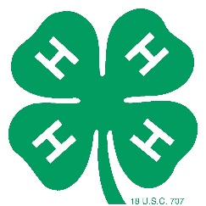
ANIMAL AND ME Program
You are invited to participate in the second annual “ANIMAL AND ME” Program, Friday, July 19th at the Warren County Fair.
The “ANIMAL AND ME” program is presented by Warren County 4-H and the Warren County Agricultural Society/Sr. Fairboard to provide differently abled youth the opportunity to show at the Warren County Fair. Youth will be mentored by 4-H teen leaders who have received training, have experience showing livestock and have a willingness to share their love of 4-H livestock projects.

OPEN HOUSE Saturday, June 22 3:00 pm-5:00 pm Bldg. I, Warren County Fairgrounds
Open house is an opportunity to meet the 4-H mentors who will be working with your child to introduce them to the animals, the show ring and 4-H opportunities.

FAIR SHOW Friday, July 19th 3:00 pm Bldg. I, Warren County Fair
The ANIMAL AND ME show will be held at 3 pm, Friday, July 19th at the Warren County Fair. This is your child’s chance to shine in the show ring at the Fair. Fair tickets will be provided and awards will be given for all participants.
MENTOR RELATIONSHIPS Mentors and participants will have opportunities to work together in the weeks prior to Fair at times established by you and your mentor.

IF INTERESTED:
- Complete the registration form below.
- Return by June 18th - ROsborne@warrencountyfairohio.org or WCAS, PO Box 58, Lebanon, OH 45036.
- Save the dates for participation in the “ANIMAL AND ME” program.
-

PARTICIPANT REGISTRATION FORM
CHILD’S NAME AGE SHIRT SIZE PARENT/GUARDIAN NAME EMAIL PHONE
SPECIAL needs/accommodations of which mentors/show personnel need to be aware:

The following species may be available to show. Please list your child’s preference:

Goats Sheep Alpacas Rabbits Miniature Horses

Your child will be assigned a mentor who you will meet at open house and will assist at the show. By signing below, you give permission for the youth mentor to email or text you/your child to encourage your child’s participation and to meet with your child throughout the program.

Parent signature

ANIMAL AND ME Program

PARTICIPANT COMMENTARY FORM
During the Show, the following information will be announced while participants are in the show ring.

Name City / School

Parents’ Names

Participant’s Interests

Participant’s Activities, Clubs or Service Work

Favorite thing about the Warren County Fair

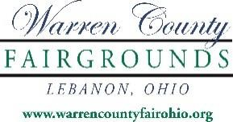
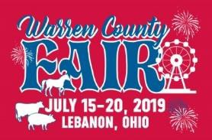

Thank you for being a special part of the “Animal & Me” program!

The ANIMAL AND ME program is a joint effort of Warren County 4-H and the WCAS Senior Fairboard. Participation this year is limited to ensure that every individual involved has a positive experience.
For further information, contact Becky Osborne, WCAS/Sr. Fair Office, 513.932.2636.

